WEB API Documentation

**Setting It Up**

Download the Scoreboards.sql data file for SQL server 2014 Management Studios.

Store the MDF file into your SQL data folder (where you store all your data files).

Now you’re ready to attach the database.

Open your Management studios and right click on database.

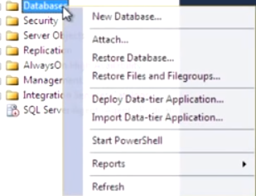

Select “Attach…”

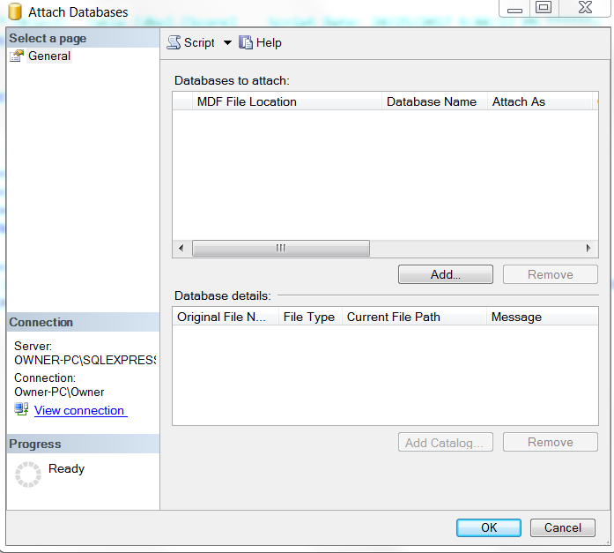

Afterwards, click “Add…”

Open up your data folder (the one you just saved Scoreboards to) and add the file you recently downloaded.

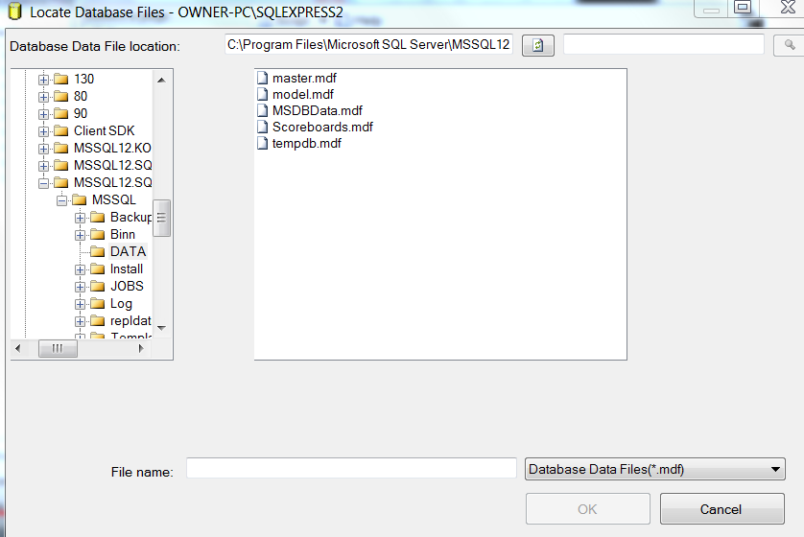

Afterwards, go ahead and click OK.

Now you should see the database “Scoreboards” if not, you might have to click refresh.

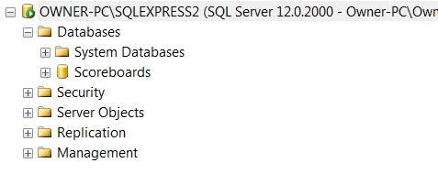

You can go ahead and open up the database “Scoreboards.”

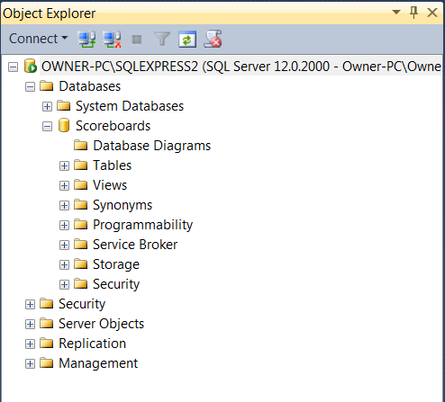

In the Scoreboard’s folder you should see two dbo files: dbo.User and dbo.Scores.

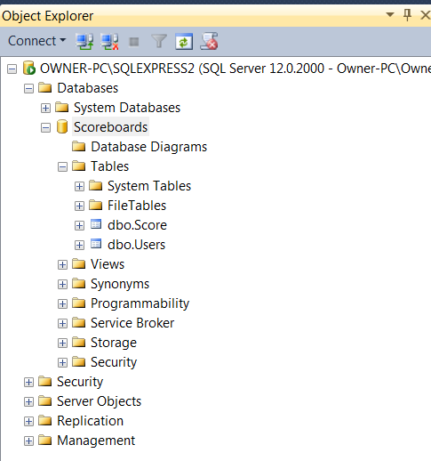

These two tables are where we store our user names and the score. Both tables have primary keys for referencing. In addition, there is a foreign key that will allow you to relate information and gather content from either table.

Go ahead and right click on the table “Scores.” Afterwards, click “Design”

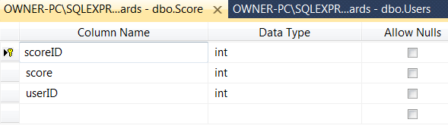

In the window, you should see three columns.

scoreID is the identification number that specifies the current instance.

score is the total points the player has obtained.

userID is a foreign key that strictly relates to dbo.User.ID.

If we need to gather information about the score we can use scoreID.score inside the queery.

**Moving on to Unity….**

Download the Unity Project “Leaderbards,” and open it through Unity game engine. Go ahead and click on the project pane and open up the scenes folder.

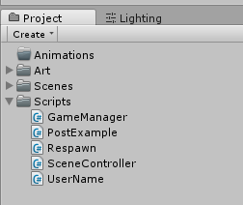

Upon opening the scenes folder, the editor should reveal “Level01.” Go ahead and double click it to start the scene.

C:\Users\Owner\Desktop\5.PNG

At the top center, you should see a play button. Go ahead and click it.

C:\Users\Owner\Desktop\6.PNG

Upon hitting play, the game will request that you insert a user name. Go ahead and provide your name.

C:\Users\Owner\Desktop\7.PNG

The game is simple. Use the mouse to click on the bubbles. For each bubble you pop, you will earn 100 points. The idea is prevent the bubbles from reaching the bottom of the screen. Be warned, the bubbles will fall faster and faster as the game progresses.

When you are defeated you will be introduced to a leaderboard. Remember the name that you’ve just provided prior to starting the game? Well, now it has been inserted into the database that you learned about earlier. After having added it to the database, it now reads the list of all names and databases that were added to that structure.

**How does it work?**

In the script PostExample.sc, the game engine requests information from a world wide web (www) and extracts it into a readable Json file. It then displays the content into a HUD file for the player to view.